TMTD-6015 Test Procedure

* TMTD Test Box
* Tm6015 Transistor (TMTD)
* Multimeter
* One Banana Jack Cord

Setup:

There are three outputs on the front of the Oscillator Box. The outputs are color coded with red, black and green and are 5V, GND and a base output, respectively. The base output can either be controlled from the internal oscillator or from the movie gate. This is controlled by a flip switch on the front of the box. The base current can be adjusted using the base current pot and the internal frequency can be adjusted using the frequency pot.

* Connect the base of the transistor to the transistor output of the TMTD Test Box. (green to green)
* Connect the Emitter of the transistor to GND. (black to black)
* Connect the Collector of the transistor to the COM on the multimeter, and connect the 5V output to the Amp measurement on the multimeter.
* Verify the Meter is measuring DC current. (The meter starts measuring AC current by default. To switch into DC mode, press the yellow button)
* Make sure transistor has good thermal contact with the thermal stage or thermal runaway will occur.

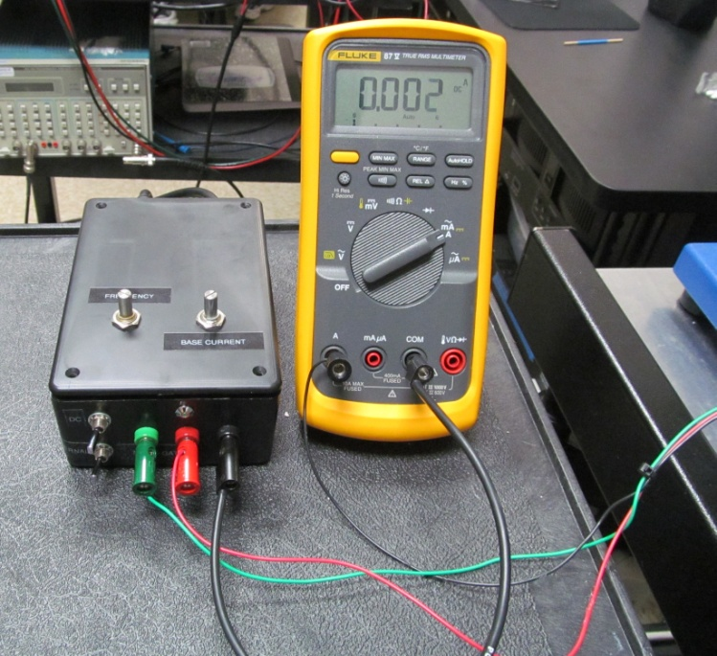

Steady State

* Open TM software
* Set the stage temp to 75°C
* Flip the toggle switch to DC mode on the TMTD test box
* Flip the toggle switch to internal on the TMTD test box
* Adjust the base current so we have approximately 3.7A flowing through the TMTD.
* Turn off Device. (toggle Power switch on the side of the TMTD Test Box)
* Under the Acquire tab, Click on the Ref Image icon.
* Turn on Device (toggle Power switch on the side of the UTD Test Box)
* Under Acquire tab, Click on Temp. Change range if needed. ( 120C is pretty typical)

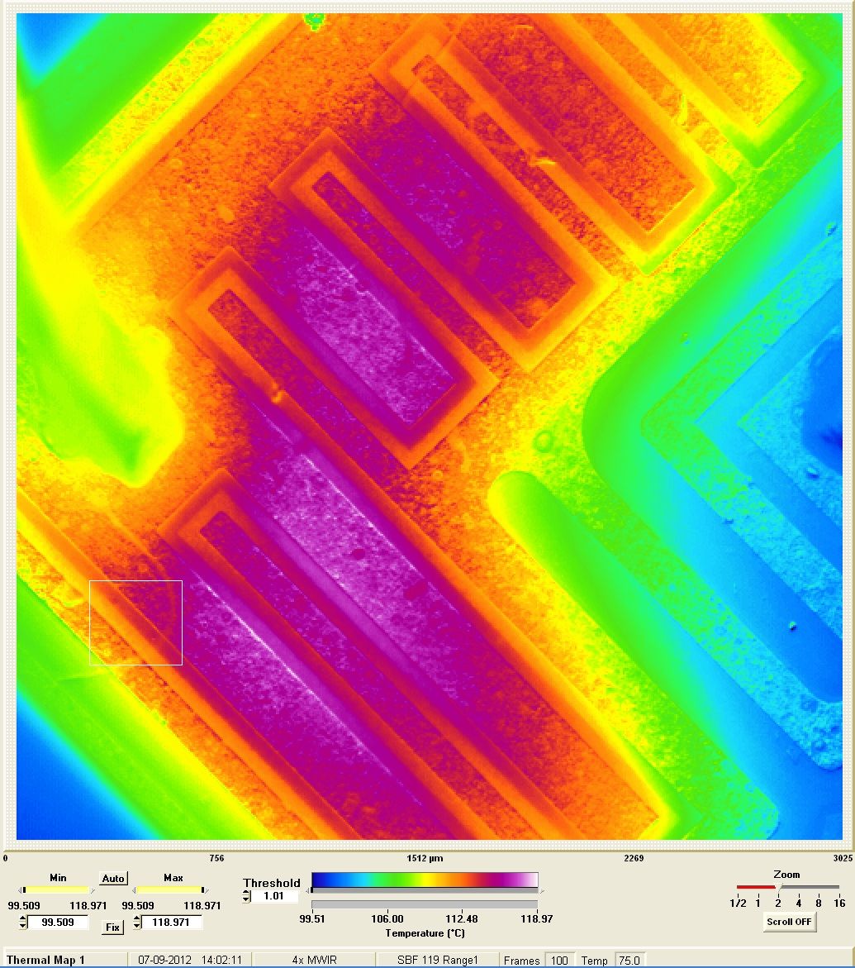

Movie Mode:

* Open TM software
* Set the stage temp to 75°C
* Under the Acquire tab, Click on the Ref Image icon.
* Flip the toggle switch to DC mode on the TMTD test box
* Flip the toggle switch to internal on the TMTD test box. (Note: This can be controlled by the Movie Gate by switching the toggle switch on the TMTD Test Box to Movie Gate and connecting the Movie Gate bnc in the back of the TMTD Test Box. The Gate ON Frames and Gate OFF Frames can be set accordingly.)
* Adjust the base current so we have approximately 3.7A flowing through the TMTD.
* Set the switch on the front of the TMTD Test Box to 555timer. The TMTD should now be toggling on/off.
* Adjust the frequency, using the frequency adjust pot, to below 5Hz. Use the blinking LED as a guide.
* Under the Movie tab, set the number of frames to 100.
* Click the start movie icon

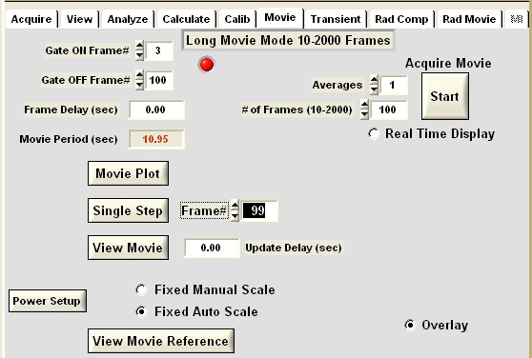

Transient:

* Open TM software
* Set the stage temp to 75°C
* Under the Acquire tab, Click on the Ref Image icon.
* Connect the trigger to the trigger output on the back of the Oscillator Box
* Flip the toggle switch to DC mode on the TMTD test box.
* Flip the toggle switch to internal on the TMTD test box.
* Adjust the base current so we have approximately 3.7A flowing through the TMTD.
* Set the switch on the front of the TMTD Test Box to 555timer. The device should now be toggling on/off.
* Under the transient tab, set the thermal frequency to 10Hz, the display to 5.00 and check the free run button.

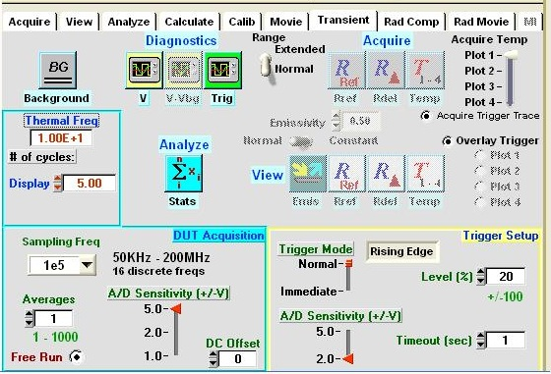

* Click the Trigger icon; adjust the frequency until you have a 10Hz signal. (You should see 5 full pulses and stop on the rising edge of the 6th pulse)

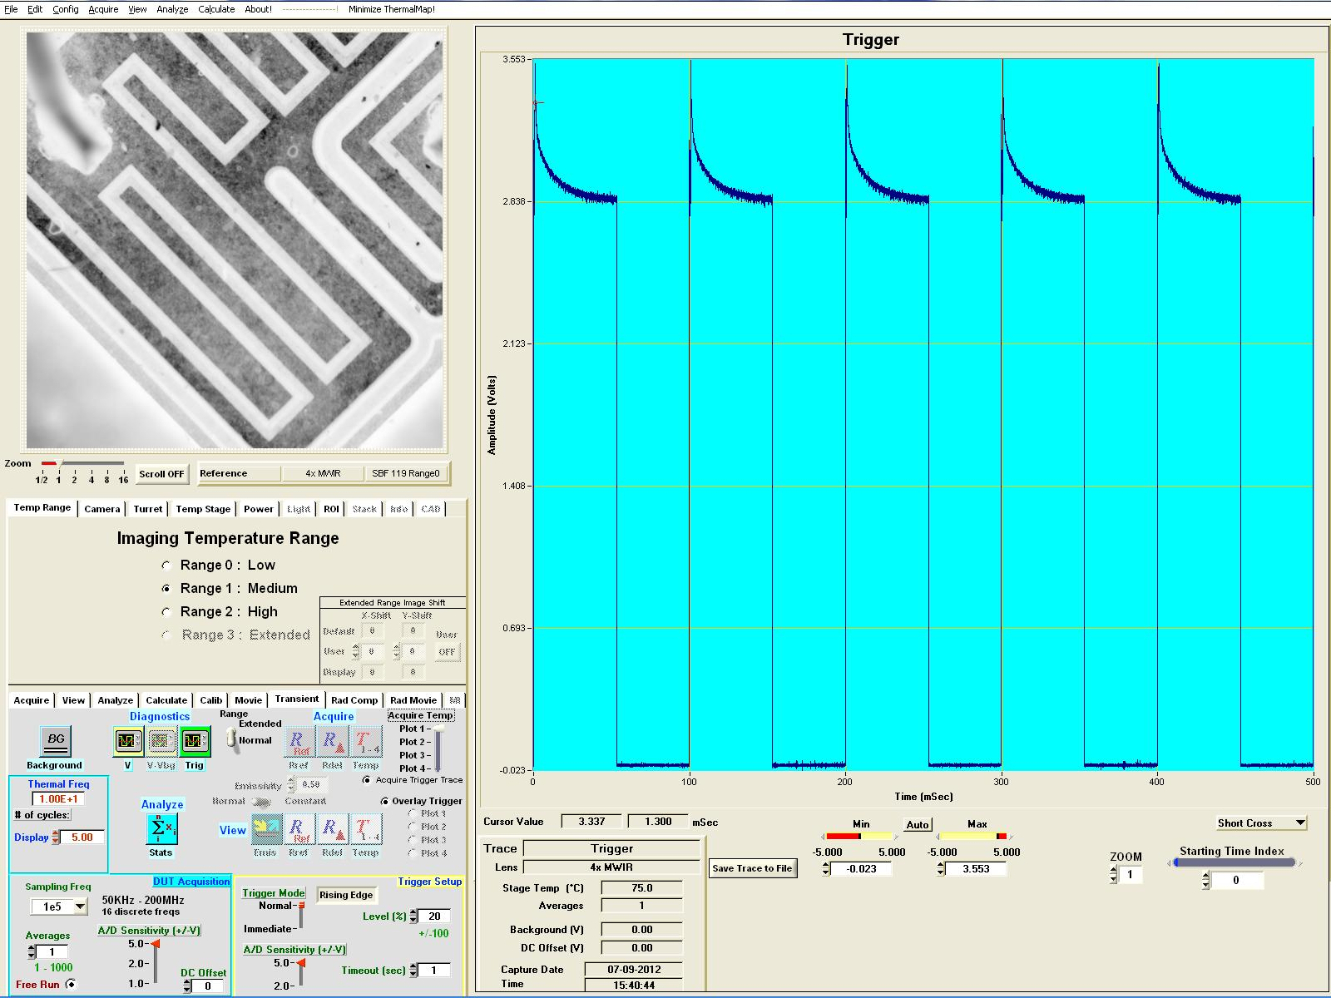

* Under the Acquire tab, click on the Temp. Make sure the defaults and box button are highlighted and place the small box in the area of the heat change
* Unbias the part.
* Move the transient camera into position
* Under the transient tab, Click on the Acquire Ref icon and click Stop once you have acquired a reference image
* Bias the part
* Under the transient tab, click on the Temp icon
* Typical change in temperature is 15C - 20C

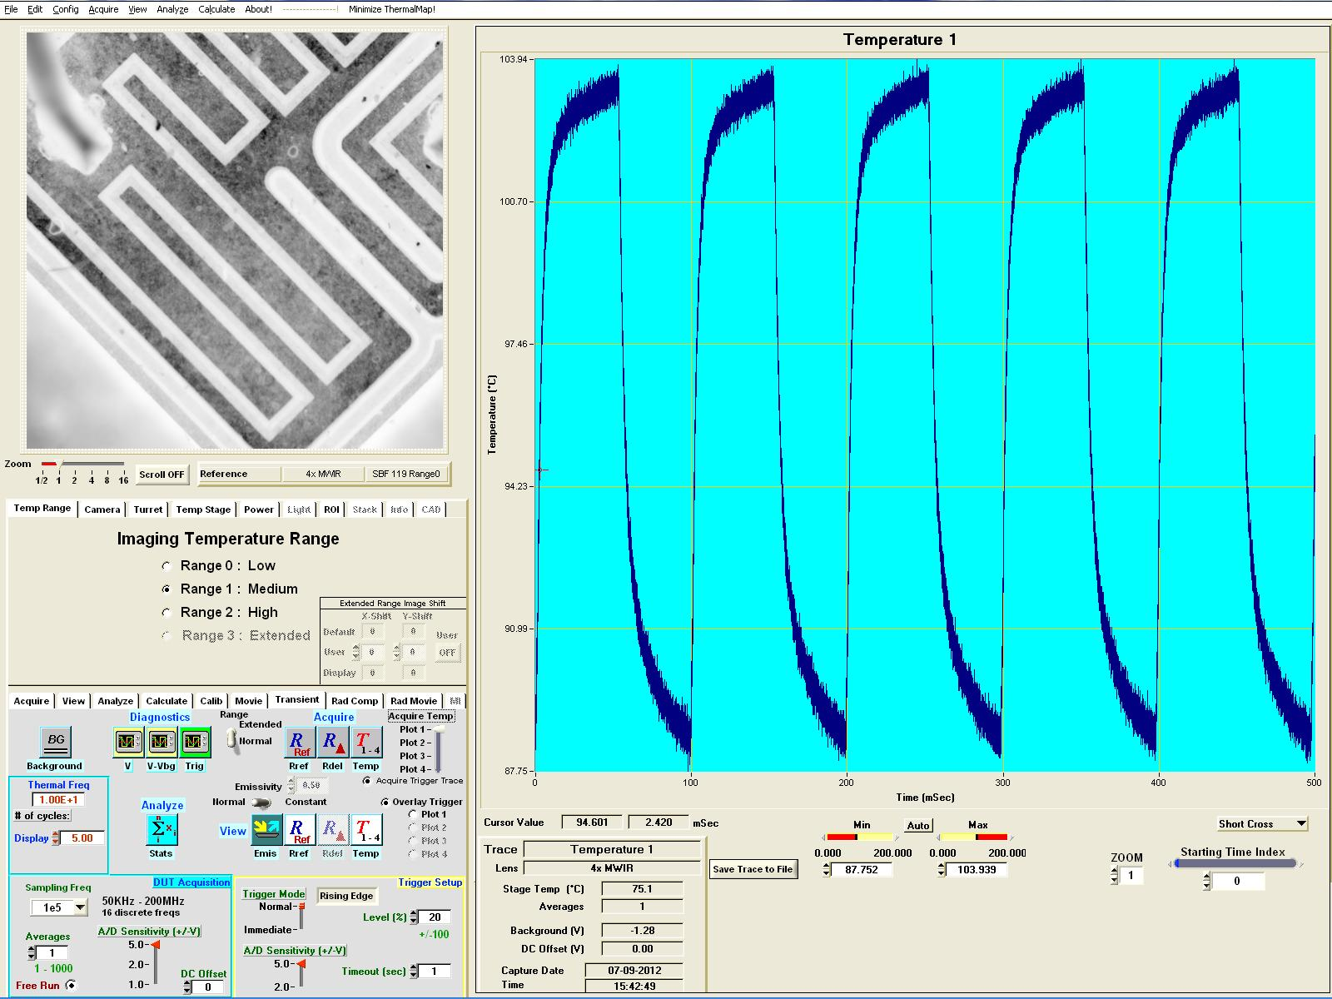

Radiance Compare:

* Adjust base pot until there is 2.2A flowing through the TMTD
* Apply Radiance compare temperature method. (Refer to Radiance Comparison Temperature Method documentation if needed)
* Typical Results for the TMTD are displayed below

